bibliographic Information ツ

Author(s): Chi Zhang; Zhong Yang; Qianhui Fang; Changliang Xu; Hao Xu; Xiangrong Xu

Title of article or book (if a chapter in a book, put the chapter # and title here, and put the title of the book in “Title of publication”):
2021 IEEE International Conference on Robotics and Biomimetics (ROBIO)
Title of publication, including Vol., Num., date (if article in magazine, newspaper, or journal):
IEEE
Page numbers (if article in magazine, newspaper, or journal):
1165-1170
Publisher:
IEEE
Date published:
2021
URL (if applicable):
https://ieeexplore.ieee.org/stamp/stamp.jsp?tp=&arnumber=9739499
MLA citation:
C. Zhang et al., "FRL-SLAM: A Fast, Robust and Lightweight SLAM System for Quadruped Robot Navigation," 2021 IEEE International Conference on Robotics and Biomimetics (ROBIO), Sanya, China, 2021, pp. 1165-1170, doi: 10.1109/ROBIO54168.2021.9739499

Direct quotes: Include Page #s (For each quote, provide some context and/or analysis; you may also want to re-state the information in your own words. Quotes from your sources, and your understanding of them, will make up the bulk of your literature review)
- 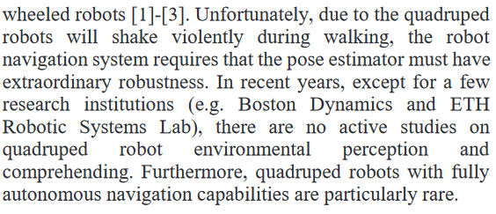p1165
- 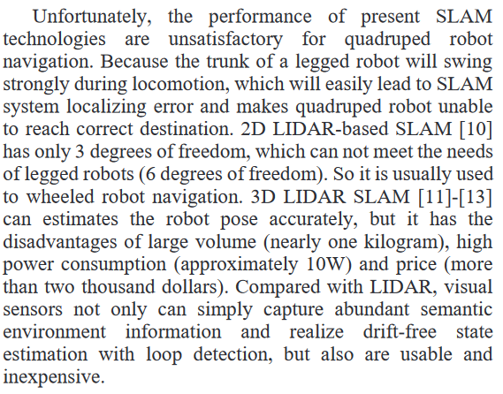p1165
- 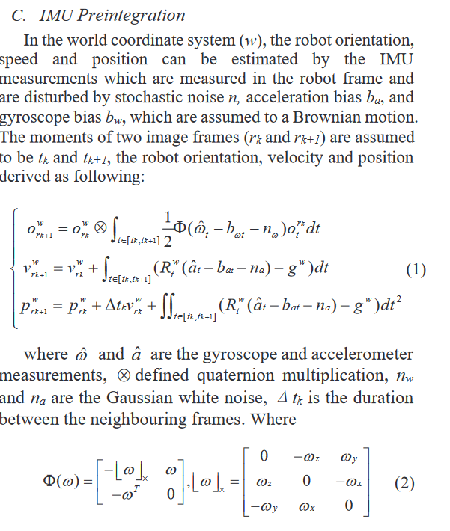p1166
- 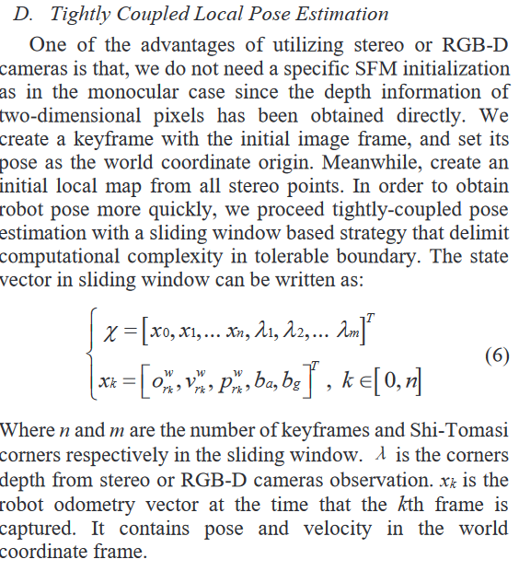1167
- 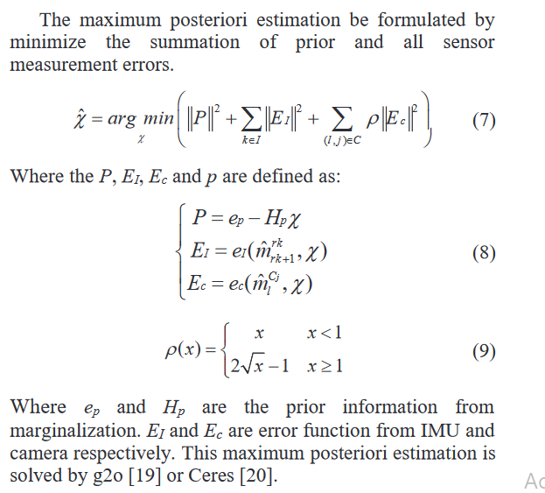p1167

Paraphrased Notes: Include Page #s (This is a space for you to track the flow of information, and the ways in which the article engages with other works.)
This is implementing slam!

Summary of Source (2-4 sentences)
This source goes in depth into the challenges and resources required to get slam running on a robot dog. Interestingly enough, they use a d435i camera, which is probably what I am going to use

Does this help me answer my question? Why or why not?
Yep! This shows how slam can be implemented on a quadruped, and how to overcome some of the major challenges

Lingering Questions
How good of a lidar can i get, and how can i get the dog to go up stairs?

Connections to other sources
Talks about slam and the jacobin matrices, but goes waaaay further into data analysis and error probability.

